 Computer organization
and Architecture
ASSIGNMENT – I

Name : BHAVISH S SHETTY
USN : ENG23CS0035
Sem : 4th
Department : Computer Science and Engineering
Sec : A
Program : B-Tech
Course : Computer organization and architecture
Date of Submission : 13-04-2025
To : . DR. BASAVARAJ N HIREMATH

1.Write ARM instructions that set bits 0, 4, and 12 in register r6 and leave the remaining bits unchanged

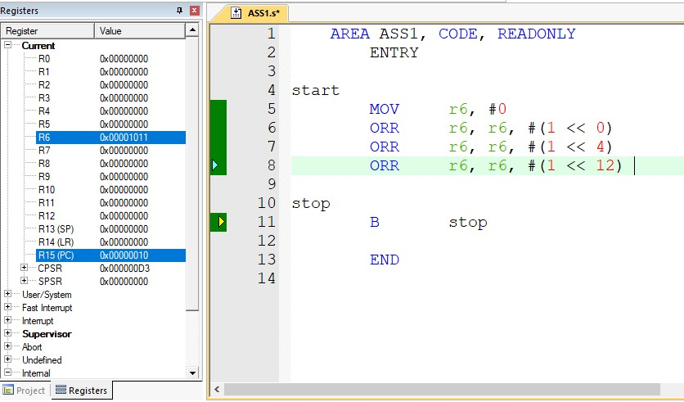

2. Write a program that takes character data “a” through “z” and returns the character in uppercase

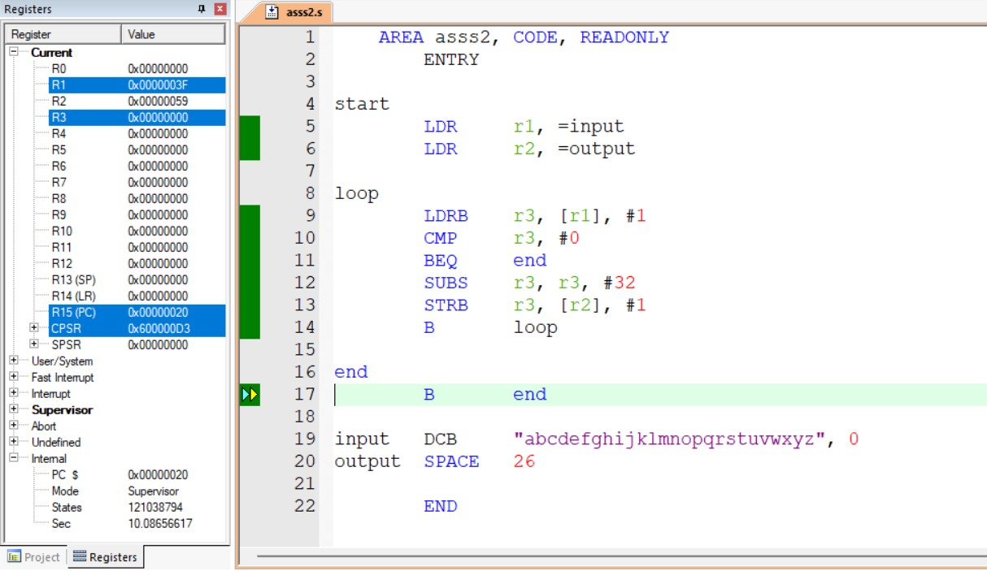

3.Write a program to count the number of ones and zeros in two consecutive memory locations.

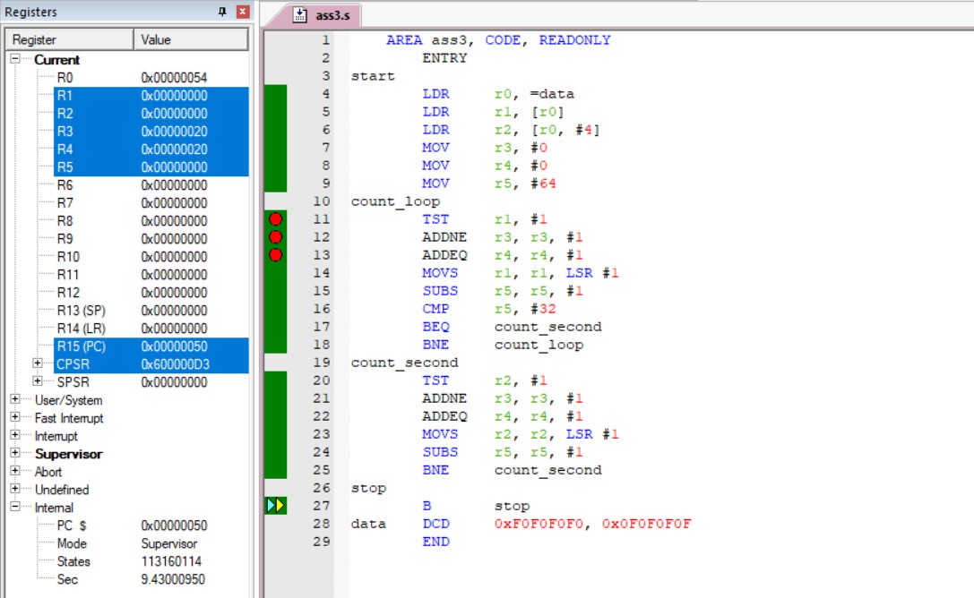

4.Write a program to arrange a series of 32-bit number in ascending and descending order.

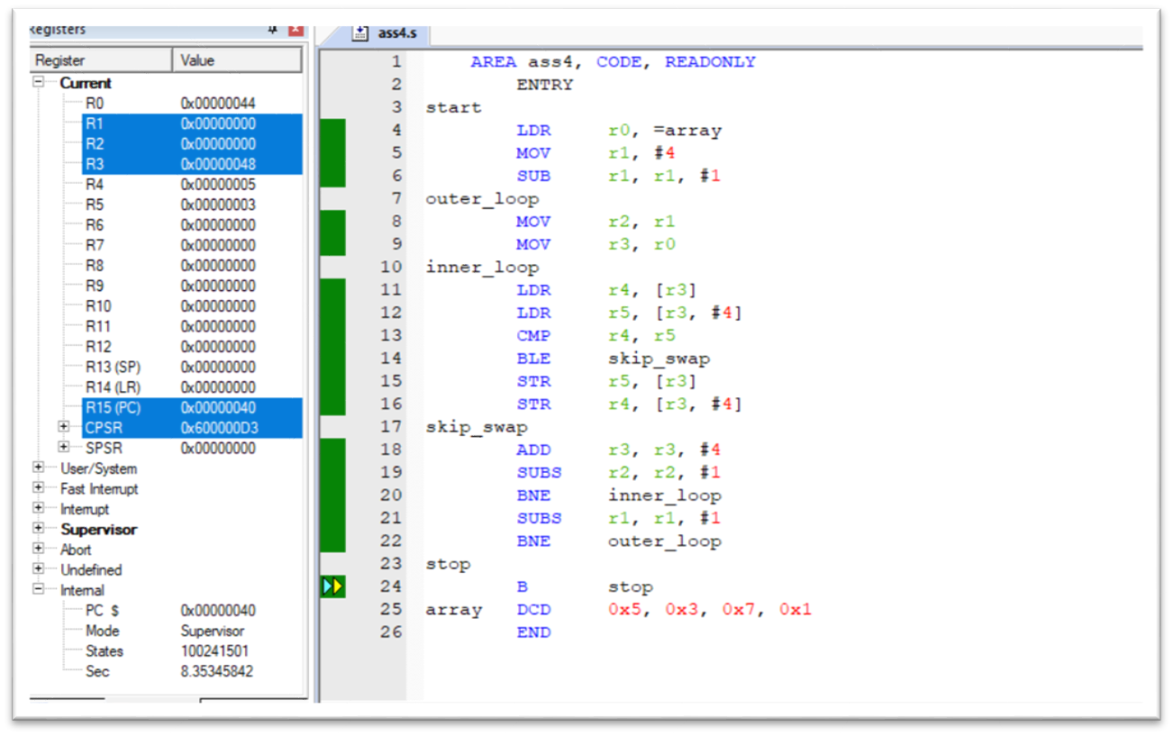

- Write a program to find the largest and smallest number in an array of 32 numbers

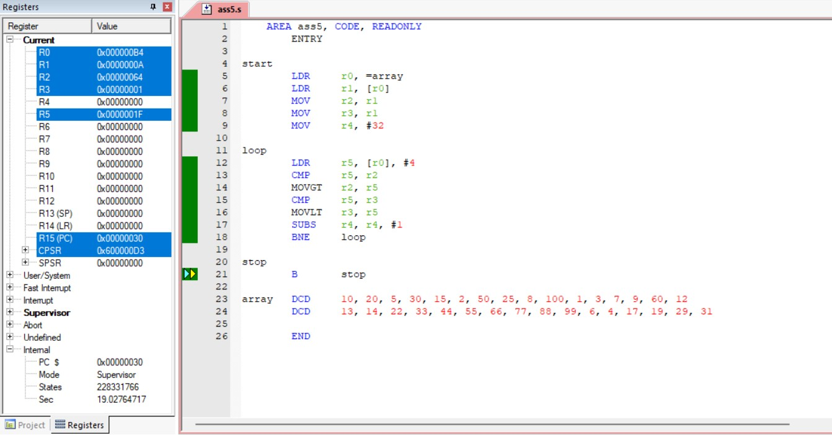

- Write a program to add an array of 16-bit numbers and store the 32-bit result in internal RAM

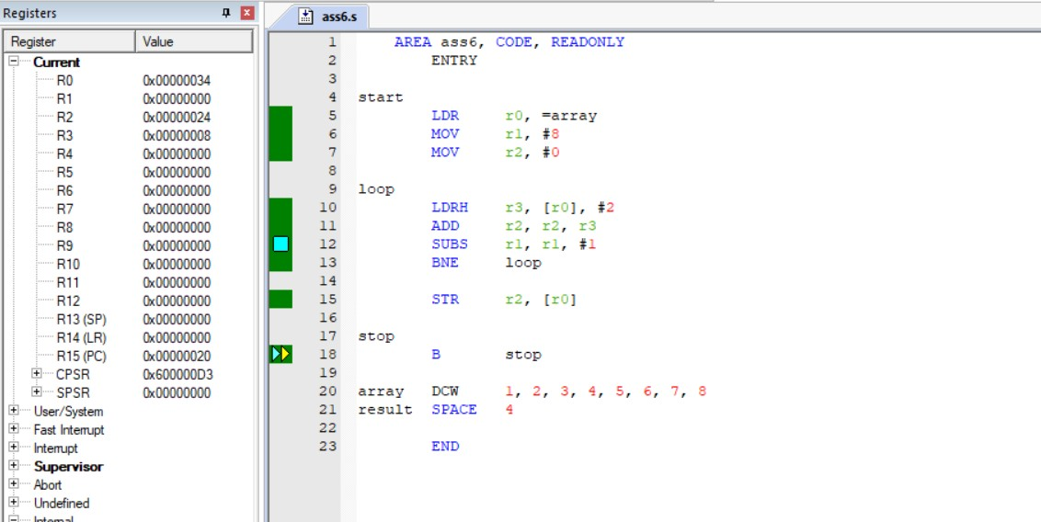

- Write a program to search a key element in a list of ‘n’ elements.

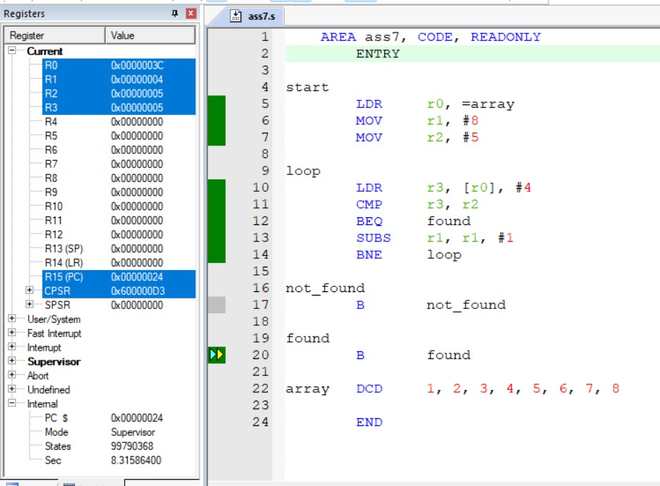

- Write a program to check whether the give string is palindrome or not.

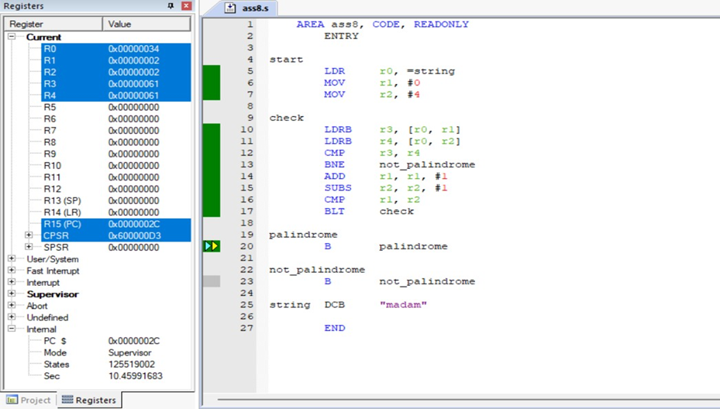

- Write a program to count the number of ones and zeros in two consecutive memory locations.



